**IOT Based Power Management and Controlled Socket**

**Abstract**

Life today is getting easier and simpler with the advancement of automation technology. Manual systems are getting replaced by automatic systems. With the rapid increase in Internet users, it has become part of life. One of its kinds is IoT, latest and emerging technology. Thinks like consumer goods, industrial goods, etc., can be networked to share information and complete the task remotely. Basic home functions and features can be controlled using IoT from anywhere in the world. It is meant to save human and electrical energy. Intel Galileo is used to integrate cloud network and wireless communication to provide users with remote control of various home appliances and storing data in the cloud. The system automatically changes according to the sensor’s data. The system designed allows the addition of a variety of devices to be controlled.

**Introduction**

The most critical problem faces by today’s world is irregular power. People in many countries don’t get the primary needs of lights, fans, etc. Researchers expect the capabilities of existing energy production will fail to meet future demand without new energy sources. We can make use of available power efficiently. A system can be created to achieve efficient use of power which monitors the environment and controls the power device and turns on only when needed. The electrical parameters like voltage, current, and frequency from a smart grid can be acquired remotely and send these real-time values using IoT.

**Proposed System**

Graphical User Interface (GUI) is used to monitor and control connected devices through an android application.  The communication protocol provides monitoring and controlling the power with more than just ON/OFF functionality. Sensors are used for sensing and monitoring environment and microcontroller is used to process the sensed data and control as well as to monitor the appliances. The microcontroller is also interfaced with the temperature sensor, LDR and PIR sensor in order to monitor humidity, light intensity and to sense the movement of people, animals, or other objects. The appliances are connected to the board through a relay which acts as an electrical switch.

**Block Diagram**

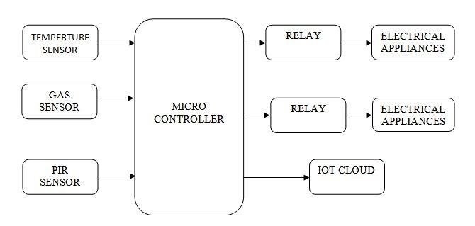

**Hardware Requirements**

* Microcontroller
* LM35
* Gas Sensor
* PIR Sensor
* Relay
* Electrical Appliances

**Software Requirements**

* Arduino IDE